L02 Participation Assignment – Data Types

Background
Explore using data types and data structures.

Procedure
Run the associated code in pycharm, command line, idle or colab.google. Answer questions and copy/paste or screen shot answers.

- Run the Python code of the following. Note the use of string formatting and length functions.
  - The first 3 letters are displayed
  - The last 3 letters are displayed
  - Copy/paste your code output below.
Pol…nic

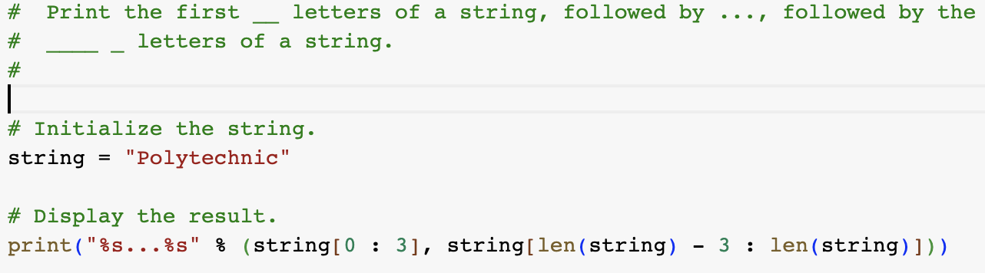

- Run the Python code of the following. Note the use of user input casting variables.
  - What happens if you type “cat” into the input field instead of a number?
Could not convert string to float: ‘cat’
  - Enter 88.99 into the input. Copy/Paste input below
88 dollars 99 cents
  - Swap the commented print line at the end of the program with the one above it. The f-string is more concise; is there a change in in the output? No
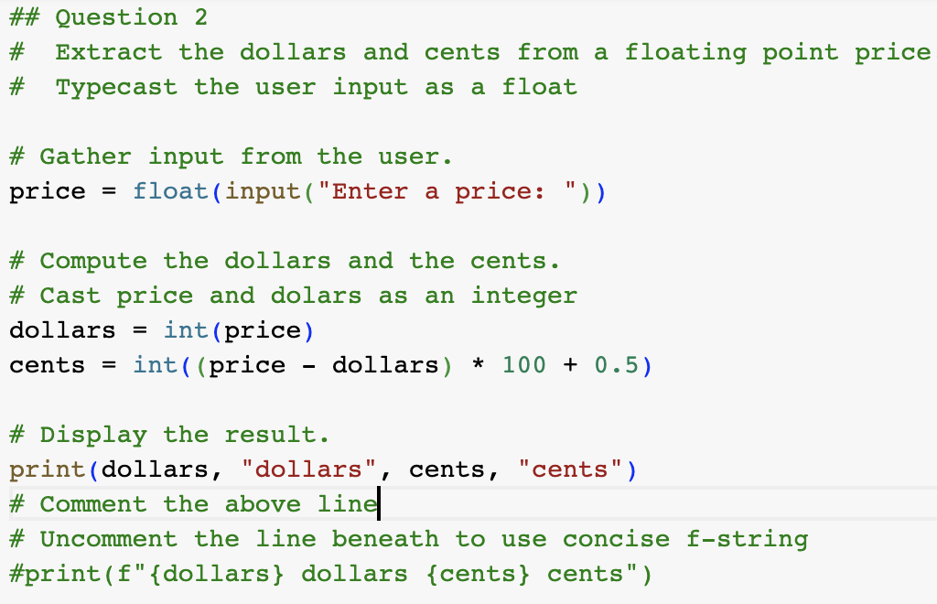
- Run the Python code of the following. Use List methods to manipulate.
  - What does names.pop do to the list? Removes the element at index 2 from the list
  - Where does the append method place ‘Jorge’? At the end of the list
  - What is the final command needed to display a sorted names list?
Print(sorted(names))
  - Show the output from this program with sorting:
[‘Fritz’, ‘Jorge’, ‘Melina’]
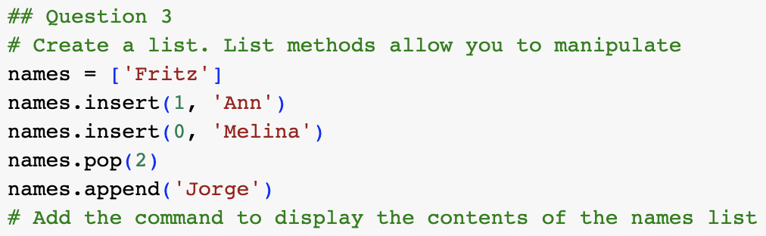
- Run the Python code of the following.
  - Copy and paste the output from running below:
Jenny James
Jennys number is 8675309
Brian has new number 5551212

